Lab 4 Lighting Materials

1. Using existing code and code from the lecture build an application that demonstrates specular highlights. Render multiple spheres with different shininess materials applied to them.  
   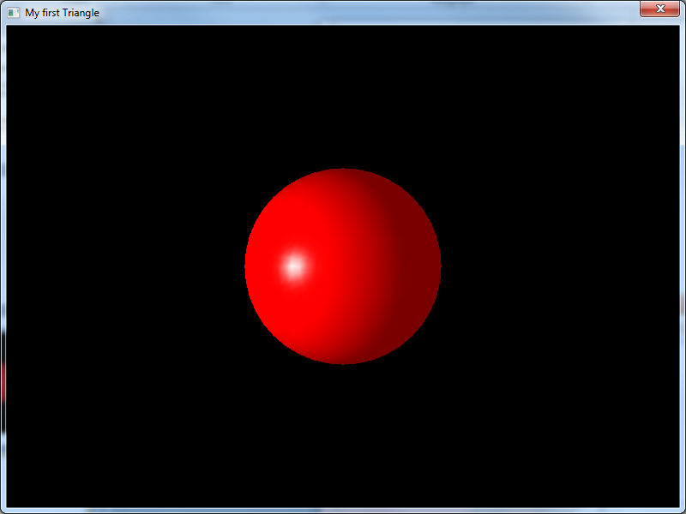
2. Build an application that shows a working light with attenuation I suggest rendering multiple objects at different distances to the light, or a large plane to show the light drop off. Use the following values as a starting point for attenuation
   1. Constant factor to 1.0f
   2. Linear factor to 0.125f
   3. Quadratic factor to 0.0f
3. Build an application and try to synthesise the following materials in appearance
   1. Red Plastic (shiny, one of the easiest thing to create)
   2. Grey rubber (very little or no specular)
   3. Metallic (very high specular, blue-ish colour)
4. Add keyboard controls to your application. Assign keys to increase/decrease the light and material properties so you can see the effect in real time. Add controls that increase and decrease the shininess of a material. Add controls for moving the light around, this should result in the specular highlight moving.